# JavaScript UI & DOM – Practical Exam

17 June 2014

# Task 3

## Task

Given the HTML (index.html), CSS (styles.css), JavaScript (scripts.js) and images **build a Handlebar template** that produces the HTML in **result.html**

You should only fill the template in the element with id “**authors-template**”.

Note that in the result some html elements have “right” class and others don’t.

## Final result

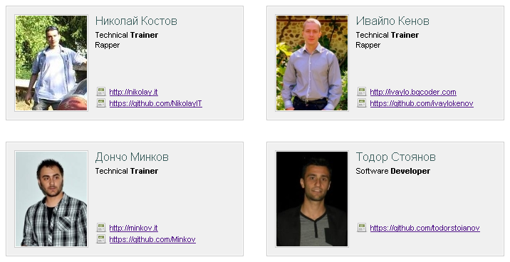

## Constraints:

* You are allowed only to edit the contents of the file "index.html " and only the template inside the element with ID "authors-template"
* You are NOT allowed to edit the contents of the JavaScript and/or the CSS files

## Files to Submit

When ready send all files in “**task-files**” directory as a single zip file.